Meeting 18
Course / Class #: CECS 4800

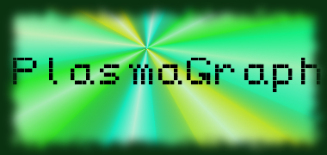
Date: 6 February 2014
Project Name: PlasmaGraph
Has been done:
1) GUI Testing. (Found various issues with Swing's EDT that have been corrected. Still need to implement robust JUnit 4 tests for all the GUIs.)
2) Additional changes to GUI-related classes. (Template gained the ability to send ChangeEvents to listeners that register with it in order to properly display its changes on the GUI.)
3) Work on the Matlab Data Reading. (Found problems with the inputs that will be provided to the project and are working with the responses that the Plasma Lab. has given us to resolve them in a flexible manner.)
4) Implemented classes in org.pvg.plasmagraph.utils.data and org.pvg.plasmagraph.utils.graphs, including a basic CSV Data Reader and Writer. (Theory is that, if we need to, we can write a CSV file with changes to the data as a temporary format. Plus, it was relatively fast and painless to create, so we did it.)

What will be done:
1) Interpolation and Outlier Search functions will be implemented.
2) Matlab and CSV Data Reading functions will be implemented in their basic form.
3) Continuing work with test generation of classes.
4) SDD: Begin work on updating some of the new versions of the GUI Class, Activity and Sequence diagrams, as well as remaking the Package diagram.

Materials Used: 2x Computers, Internet connections, Microsoft Visio / Dia (Diagramming Tools), Eclipse / NetBeans IDE (Programming Tools).

Group Members: ________________________________
Gerardo A. Navas

________________________________
Daniel Quintini
Professor:

________________________________
Prof. Luis A. Ortiz

